**School of Isolated and Distance Education**

**SEMESTER TWO EXAMINATION 2018**

**COMPUTER SCIENCE**

**Unit 1 and 2: Year 11 ATAR**

**Student Name: ____________________________________________**

**SIDE Teacher: ____________________________________________**

**SIDE Student Coordinator: ____________________________________________**

**Base School: ____________________________________________**

**SUPERVISOR’S DECLARATION**

I declare that this examination paper has been completed by the student named above. The time and resource restrictions have been observed and the student has NOT accessed notes, texts, reference books, the internet, a computer, a calculator or a mobile phone unless otherwise specified. I understand that breaches of the examination rules could lead to an examination paper being cancelled or having an examination mark significantly lowered.

**Supervisor’s Name: ___________________________________________**

**Signature: _________________________ Date _____________**

**TIME ALLOWED FOR THIS PAPER**

Reading time before commencing work: ten minutes

Working time for paper: three hours

**MATERIALS REQUIRED/RECOMMENDED FOR THIS PAPER**

**To be provided by the supervisor**

This Question/Answer Booklet

Source Booklet

**To be provided by the candidate**

Standard items: pens, pencils, eraser, correction fluid/tape, ruler, highlighters

Special items: non-programmable calculators, MATHOMAT and/or Mathaid and/or any system flowchart template

**NO OTHER ITEMS MAY BE TAKEN INTO THE EXAMINATION ROOM**

**IMPORTANT INFORMATION FOR CANDIDATES**

**No other items may be taken into the examination room. It is your responsibility to ensure that you do not have any unauthorised notes or other items of a non-personal nature in the examination room. If you have any unauthorised material with you, hand it to the supervisor before reading any further.**

**Structure of this paper**

|  |  |  |  |  |  |
| --- | --- | --- | --- | --- | --- |
| Section | Number of questions available | Number of questions to be answered | Suggested working time (minutes) | Marks available | Percentage of exam |
| Section One:  Short answer | 20 | 20 | 70 | 86 | 40 |
| Section Two:  Extended answer | 4 | 4 | 110 | 106 | 60 |
|  |  |  |  | **Total** | 100 |

**Instructions to candidates**

1. The rules for the conduct of Western Australian external examinations are detailed in the *Year 12 Information Handbook 2018*. Sitting this examination implies that you agree to abide by these rules.

2. Write your answers in the spaces provided in this Question/Answer Booklet. A blue or black ballpoint or ink pen should be used. Wherever appropriate, fully labelled diagrams, tables and examples should be used to illustrate and support your answers.

3. You must be careful to confine your responses to the specific questions asked and to follow any instructions that are specific to a particular question. Where no specific instructions are given, you should feel free to use a range of formats to express your knowledge and understandings.

4. Spare pages are included at the end of this booklet. They can be used for planning your responses and/or as additional space if required to continue an answer.

* Planning: If you use the spare pages for planning, indicate this clearly at the top of the page.
  + Continuing an answer: If you need to use the space to continue an answer, indicate in the original answer space where the answer is continued, i.e. give the page number. Fill in the number of the question(s) that you are continuing to answer at the top of the page.

**Section One: Short answer** **40% (86 Marks)**

This section contains **20** questions. You must answer **all** questions. Write your answers in the spaces provided.

Spare pages are included at the end of this booklet. They can be used for planning your responses and/or as additional space if required to continue an answer.

* + Planning: If you use the spare pages for planning, indicate this clearly at the top of the page.
  + Continuing an answer: If you need to use the space to continue an answer, indicate in the original answer space where the answer is continued, i.e. give the page number. Fill in the number of the question(s) that you are continuing to answer at the top of the page.

Suggested working time: 75 minutes.

**Question 1 (4 marks)**

There are a number of types of system development methodologies including prototyping and the system development life cycle (SDLC).

1. Outline two advantages of using the SDLC methodology. (2 marks)

1. Outline two disadvantages of using the SDLC methodology. (2 marks)

**Question 2 (6 marks)**

Describe the following stages of the system development life cycle and name an activity in each.

1. Analysis (3 marks)

activity

1. Implementation (3 marks)

activity

**Question 3 (2 marks)**

Use the spreadsheet below to answer the following questions:

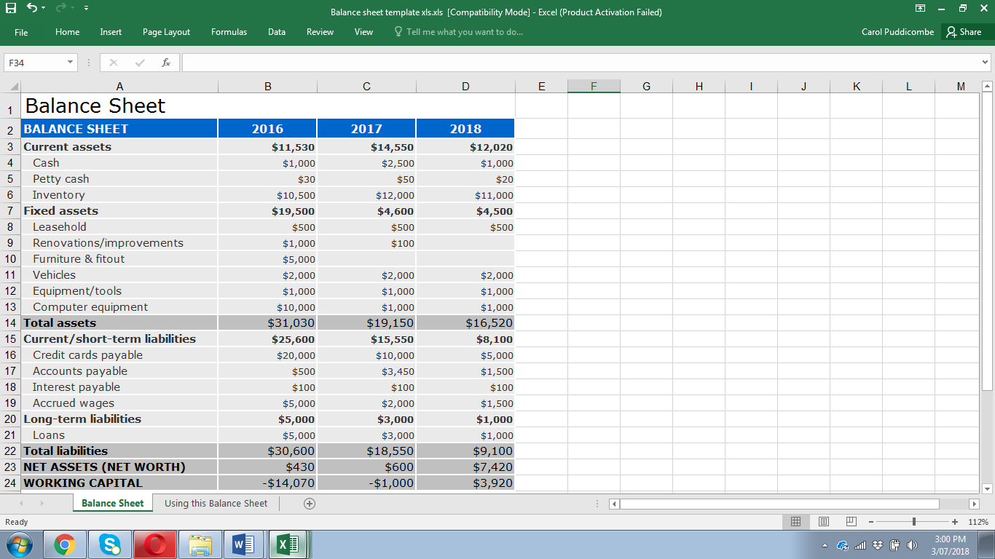

1. Write the formula that would be used in cell D23. (1 mark)

1. Write the formula that would be used in cell B14. (1 mark)

**Question 4 (3 marks)**

Explain the boot process, including POST.

**Question 5 (6 marks)**

Use the following scenario to create an accurate Context Diagram.

LIM fashions is a boutique clothing store situated in the city. The following outlines their Customer sales system. A customer decides to purchase a number of garments and gives these to the cashier. The cashier totals these and asks for the total amount. The customer gives their credit card details. Once paid the cashier gives the customer a receipt. Once the transaction is complete the information is sent to Head Office.

**Question 6 (6 marks)**

Explain the process of the fetch-execute cycle and include the role of the arithmetic logic unit (ALU), program counter and registers.

**Question 7 (4 marks)**

Outline the following database terms with an example:

1. Relation (2 marks)

1. Record (2 marks)

**Question 8 (6 marks)**

There is an issue with the entity relationship diagram (ERD) below. Resolve the issue and draw an updated diagram. Include any primary and foreign keys that are required.

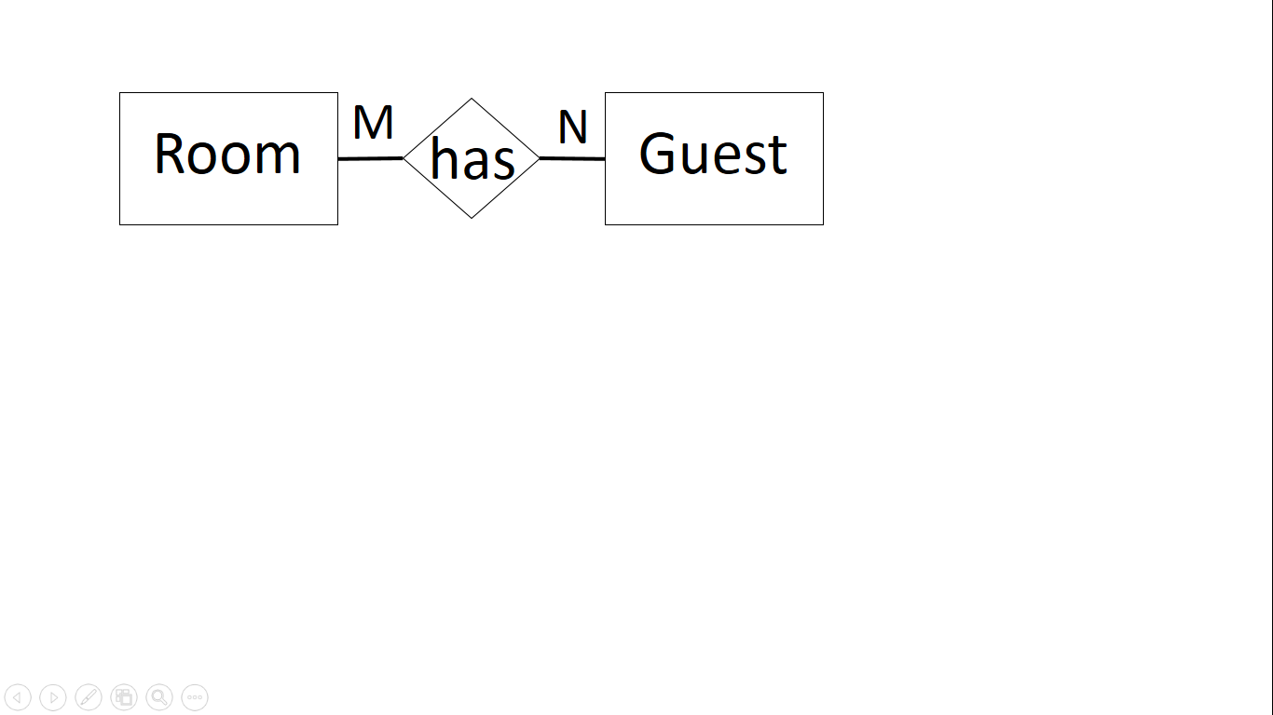

**Question 9 (4 marks)**

Outline **two** legal issues that relate to the personal use and storage of data.

One

Two

**Question 10 (2 marks)**

Outline the difference between primary and secondary storage.

**Question 11 (4 marks)**

Describe the purpose of the following utility software.

1. Defragmenter (2 marks)

1. File compression (2 marks)

**Question 12 (2 marks)**

Outline a key difference between freeware and open source software licencing.

**Question 13 (2 marks)**

Consider the following examples of code. Identify which type of programming language these belong to. The first one has been done for you.

|  |  |
| --- | --- |
| 0110 1110 | Machine |
| IF x = 5  then y =3  else y = 1  ENDIF |  |
| mov ecxm ebx  mov esom edx  mov edx, r9d  mov rax, rdx |  |

**Question 14 (2 marks)**

Outline **one** difference between a test first iteration and a test last.

**Question 15 (11 marks)**

The agricultural show would like to have an algorithm created that states the award the contestant has won based on the total score received by three judges.

You are required to create an algorithm in pseudocode to solve this problem.

Note: The total score must be between 0 and 20.

A total score between 0 and 11 award equals none.

Between 12 and 14 award equals bronze, between 15 and 17 award equals silver and between 18 and 20 equals gold. Output the award.

**Question 16 (3 marks)**

A programmer is not sure which data type should be used for decimal places in their algorithm. Explain which type should be used.

**Question 17 (4 marks)**

Convert the following to the decimal number system and show all workings.

1. 1001 1110 (2 marks)
2. 0111 0001 (2 marks)

**Question 18 (2 marks)**

Convert the following decimal number into binary.

41

**Question 19 (10 marks)**

1. A company wants to set up a network and they are unsure which type to create. They are a small business with 9 computers, a server and a printer. They were told that a peer to peer network would be sufficient instead of a client server. Justify why you disagree with this statement. (4 marks)

1. The company is also not sure which transmission media to use.

Explain **two** differences between using shielded twisted pair and fibre optic. (3 marks)

1. The company have decided to purchase some laptops as the employees like to move to different areas in the office. Justify which type of transmission media should be installed. (3 marks)

**Question 20 (3 marks)**

There are a number of communication protocols that are used within networks.

1. Explain the different use between Hypertext transfer protocol secure (HTTPS) and Hypertext transfer protocol (HTTP). (2 marks)

1. Identify the additional protocol that is used with HTTPS. (1 mark)

**End of Section One**

**Section Two: Extended answer 60% (106 Marks)**

This section contains **four (4)** questions. You must answer **all** questions. Write your answers in the spaces provided.

Spare pages are included at the end of this booklet. They can be used for planning your responses and/or as additional space if required to continue an answer.

* + Planning: If you use the spare pages for planning, indicate this clearly at the top of the page.
  + Continuing an answer: If you need to use the space to continue an answer, indicate in the original answer space where the answer is continued, i.e. give the page number. Fill in the number of the question(s) that you are continuing to answer at the top of the page.

Refer to the Source booklet provided to help answer this section.

Suggested working time: 75 minutes.

**Question 21 (29 marks)**

1. TSU pharmaceuticals have employed you to analyse their current system. Explain **two** activities you would undertake in the preliminary analysis stage of the system development life cycle (SDLC). (6 marks)

One

Two

1. They have given you a 4-week timeframe to conduct the preliminary analysis and report to them on how long it will take to rectify their problems. Explain the main tool you will use to keep on schedule and meet this deadline. (3 marks)

1. Use the information from the source booklet and draw a context diagram to illustrate the *request for fund system* below. (7 marks)
2. Use the information from the source booklet and draw a Level 0 data flow diagram (DFD) to illustrate the *request for fund system* below. (13 marks)

**Question 22 (22 marks)**

Your report to TSU pharmaceuticals is completed on time and you are awarded the contract to update their infrastructure. Your findings indicate that they do not have a standard operating system and their hardware is more than 4 years old.

1. Explain **three** benefits that the company will have by installing a standard operating environment. (3 marks)

1. The latest pharmaceutical software that they would like installed has the following minimum specifications - multicore Intel ® processor with 64-bit support, 4GB RAM, 10.5GB hard disk space and a 64-bit operating system.

Your recommendation is that they should purchase desktops with the following specifications - Dual core 2.4 GHz+ (i5 or i7 Intel or equivalent AMD), RAM 16 GB, 1TB hard drive, 23” monitor, Windows 10 operating system (64 bit).

Explain, using examples, why this would be your recommendation. (3 marks)

1. TSU pharmaceuticals administration are on the 4th floor of the head office building illustrated below. Indicate below where you would place the following network and hardware components and the transmission media you would use: router, switch firewall, WAP, 7 computers, 1 printer, 1 server. Explain your reasons. (10 marks)

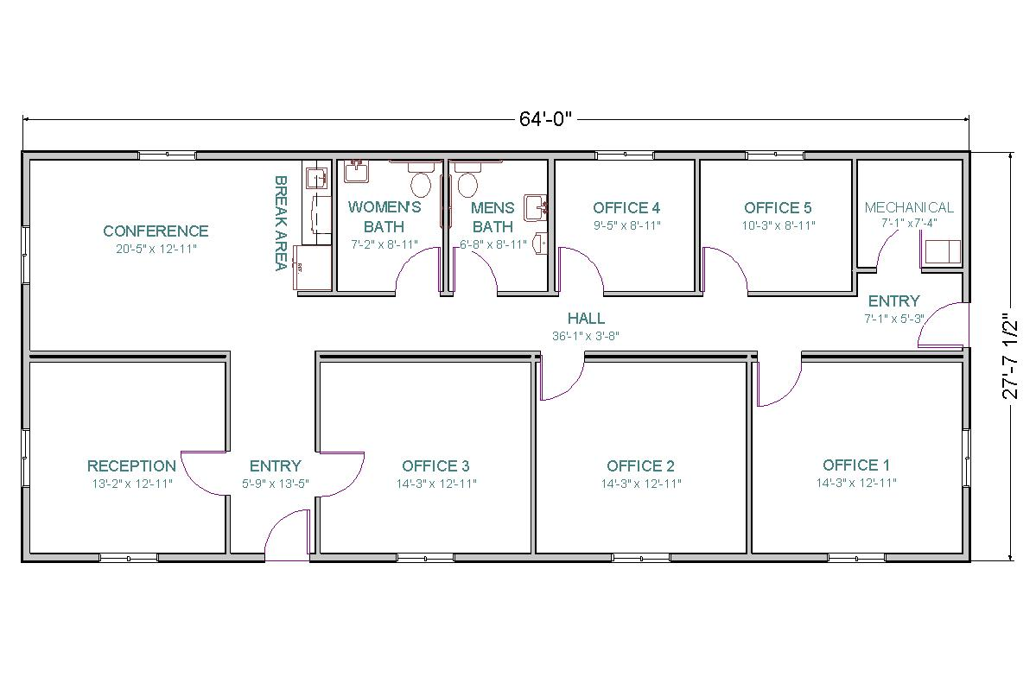Explanation for placement.

|  |
| --- |
|  |
|  |
|  |
|  |
|  |
|  |
|  |
|  |
|  |
|  |
|  |
|  |
|  |
|  |
|  |
|  |
|  |
|  |
|  |
|  |
|  |
|  |

1. TSU pharmaceuticals do not currently have any method to protect themselves from malware.
2. Describe a method of protection that could be use. (2 marks)

1. Describe **two** types of malware that could infect their system. (4 marks)

**Question 23 (26 marks)**

1. Use the information from the source booklet and complete the algorithm to display the menu in this application. You do not need to create any of the procedures. Ensure that you display all choices to the user. (9 marks)

Begin {Main Program}

End

1. Use the information from the source booklet and create a flow chart to represent the algorithm required. (11 marks)

Begin

1. The algorithm below is used to check the outcome of the test results. (6 marks)

BEGIN

count 🡨 0

total 🡨 0

WHILE count <5 do

read(test)

count 🡨 count + 1

total 🡨 total + test

ENDWHILE

IF total > 1000

THEN output(“Success”)

ELSE output(“Resubmit”)

ENDIF

END

Complete the trace table below with the following data.

*test* – 150, 260, 140, 300, 58

|  |  |  |  |  |  |
| --- | --- | --- | --- | --- | --- |
| count | total | count<10 | test | total>1000 | output |
|  |  |  |  |  |  |
|  |  |  |  |  |  |
|  |  |  |  |  |  |
|  |  |  |  |  |  |
|  |  |  |  |  |  |
|  |  |  |  |  |  |

**Question 24 (28 marks)**

1. Use the table from the source booklet to create an accurate entity relationship diagram (ERD) using Chen’s notation that represents the data that can be used by a relational database.

Ensure you include any entities, relationships, cardinality, primary and foreign keys required. (15 marks)

1. Use the spreadsheet information from the source booklet to answer the following questions
2. In Table 1, write the formula that would be in cell H4. (1 mark)

1. In Table 1, write the formula that would be in cell J8. (1 mark)

1. In Table 1, write the formula that would be in cell J12 (2 marks)

1. In Table 1, write the lookup formula that would be in cell B9. The lookup table is in Table 2. (4 marks)

1. The pie chart in the source booklet is not easy to read. In the space below, create a column chart to replace the pie chart. (6 marks)

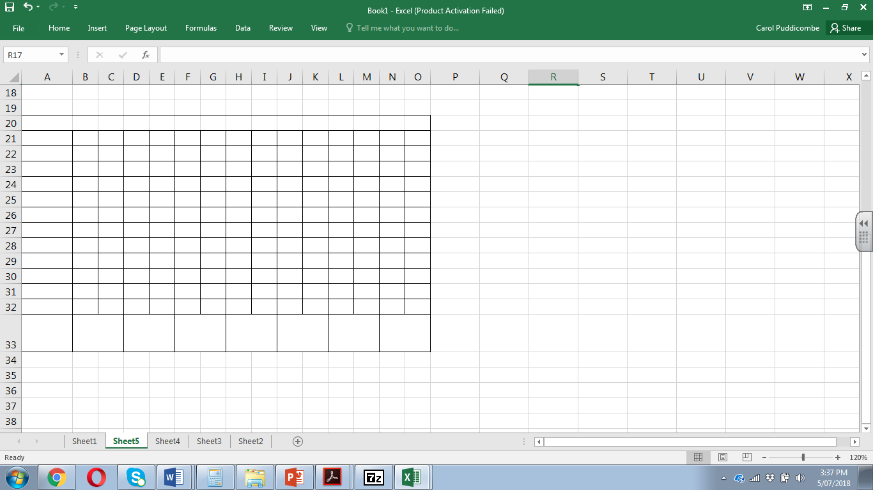

End of Questions

Additional working space

Question Number:___________

Additional working space

Question Number:___________

Additional working space

Question Number:___________